CLAUDE 2.5D ANIMATION MODEL PDF

SHORTS:

Transcript of The Ancient Jar That Warned an Empire

He put a bronze ball in a dragon's mouth and told the emperor, "If this ever falls out, run." The whole court burst out laughing. You see, there were eight dragons coiled around a giant bronze jar, each holding a ball over a frog's open mouth. But the emperor had the biggest army in the world, and he wasn't about to run from a jar. Weeks later, a ball fell, but nothing happened. Not even a ripple in the emperor's wine. Now, they laughed even harder. The emperor called it the world's most expensive toy and threw the inventor out of the city, jar and all. So he dragged it up a hill outside the walls and lived there alone. Then one night a ball dropped. Then another. Then all ate at once. He ran to the city gates, screaming for everyone to get out. Hey, it's the toy guy. Did your frogs get hungry again? The guards laughed him all the way back up the hill. The next morning, the palace was a pile of rubble. Inside the jar hung a heavy pendulum with a rod pointing at each dragon. The slightest nudge and the pendulum swung into a rod. The rod snapped the dragon's jaw open and the ball dropped. One ball meant a nudge from far away.

Transcript of He Was A Genius #shorts #movie

The man only had $10 to his name, but ordered [music] the most expensive steak on the menu. As soon as the waiter left, he took off his sunglasses [music] and checked his surroundings. Soon, the $200 steak was brought to his table. He began carefully examining it and used his finger to feel the internal temperature of the steak. After that, he stared into the waiter's soul while shaking his head in disapproval. He exclaimed that the steak was ice cold. The waiter was shocked, but still had to comply with the guest, so he took the steak back. However, when the second steak arrived, the man didn't even look at it before immediately sending it back. Turns out he wasn't here just for a free meal. He had a bigger plan. The man continued sending the steaks back until the head chef got so frustrated that he decided to just cook the steak himself. Fearing the [music] man might be a famous food critic, he used all 30 years of experience to create the most beautiful steak ever seen. But once [music] again, the man did not approve. The waiter didn't know what to do, so he called the head chef over. Immediately, the man began pointing [music] out multiple flaws with the steak. The chef felt insulted. He wanted nothing but to kick the man out. Just then, the man said he was a chef himself. And if they let him into the kitchen, he would show them how it's done. Sick of the man's complaining, the head chef actually agreed. Turns [music] out the man was never a chef and has only worked at McDonald's before. But using his knowledge, he started preparing the pastry. He brushed it with egg wash before placing the beef. And not knowing [music] what to do, he placed three slices of American cheese onto it. Just like a burger, he drew some cool looking patterns on the top and soon enough it was time to plate. He made a design with some barbecue sauce he found and added chilies for decoration. As soon as everyone tasted it, the head chef became even more angry. Turns out he had been fired on the spot and the man was instantly hired to be the new head chef.

Transcript of The Job Nobody Wants in Japan

It's impossible to get fired in Japan, but companies found something way worse. Imagine your boss walks you past your desk to a tiny room with no computer and no work. Just a ticking clock and a guy with his feet up scrolling on his phone like he's on vacation. Your new job, your boss says, is nothing. Just sit here until 6:00. And you're thinking, wait, I'm getting paid for this? At first, it's paradise. Then your co-workers start staring when you walk past. The emails stop and your old desk already has someone else's family photos on it. Every Friday, your boss pops his head in with a big smile to ask how you're enjoying your new role. Still, the guy in the corner has been doing this for 3 years and looks happier than anyone in the building. So, if they want to pay you to do nothing, fine. You kick your feet up right next to him. Then, one Monday, you walk in and he's gone. His chair is pushed in, his desk is cleared, and nobody will tell you where he went. You see, Japanese law makes it almost impossible to fire someone. But there's no law against making them miserable. So they take away your work and your friends and just wait because nobody can do nothing forever.

Transcript of Your Brain's Secret Idea Zone

If you fall asleep holding two steel balls, you might wake up a genius. You see, first you put two metal plates on the floor, sit down right above them, and hold a steel ball in each hand. Then you just let yourself drift off. Now, here's the weird part. The second you fall asleep, your hands go limp, the balls smash into the plates, and the noise jolts you awake. Sounds like the worst nap ever. But Thomas Edison was rumored to do it on purpose. That's because right before deep sleep, your brain hits a strange halfway state called hypnogogia, where it starts connecting ideas. It never would while you're awake. Normally, you sink right past it and forget everything.

LONG FORM:

Transcript of What IF You Were 10x Faster?

You wake up late. School starts in 1 minute. You grab your bag, step out the front door, and you're sitting at your desk before the bell even rings. [music] >> Did you just leave? >> I'm already here. So, what if you were [music] 10 times faster? Here's how it works. Your legs move 10 times faster than before. Every stride, every push off the ground, 10 times the speed. You look exactly the same, but your brain, your eyes, [music] your reflexes, those stay normal. Remember that. It matters later. Say your top sprint today is 25 km an hour. That's a pretty normal sprint for a teenager. Now it's 250. That's faster than a car on the highway. That's faster than most race cars on a straight. The fastest human who ever lived, [music] Usain Bolt, topped out at about 44 km an hour. You'd pass him like he's standing [music] still. 100 m. You'd run it in under a second and a half. Bolt's world record is 9.58 seconds, and nobody has beaten it [music] since 2009. So, you show up to track tryyouts just to see. >> Okay, on my whistle. 3 2 1. >> He blows the whistle. He looks down at his stopwatch. He looks back up. You're already standing at the finish line holding his water bottle. >> Run that again. Run that again. >> Coach, I already ran it twice. Now, here's why this is so hard to believe. Scientists [music] actually tested what stops humans from running faster. They put sprinters on a special treadmill that measures every footstep. [music] And it turns out the limit isn't how hard your legs can push, it's how fast. When an elite sprinter runs, each foot touches the ground for [music] less than a tenth of a second. That's all the time they get to push. Your muscles just can't fire any quicker than that. Yours [music] can. Your feet touch the ground for about a hundth of a second. Tap tap tap so fast it sounds like a drum roll. And at first, it's the best thing that has ever happened to you. You're never late again. You speedrun every chore your mom gives you. Dishes, laundry, lawn done before the commercial break is over. You get a job delivering pizza and you deliver across the whole town faster than the pizza place can make them. Bro, I literally just hung up the phone. That'll be $14.99 and the pizza shows up still steaming. >> Bro, you're doing the Naruto run. >> It actually works, though. You join the soccer team on your first game. You run past every single player on the field all the way to the goal and then you look down. The ball is still back at midfield. Turns out you can only kick it as fast as your feet can find it. Maybe try defense. >> On weekends, you run to the next city for lunch, 100 km away. It takes you less than half an hour. You're back before your food would have even been delivered. But then you start noticing the problems. And the first one is the air. At 250 km an hour, the air hitting your face is almost as fast as a category 5 hurricane. And here's the thing about air. It pushes back harder the faster you go. Not a little harder, way harder. Go 10 times faster and the air fights you 100 times harder. Your eyes water so hard you can't see. A bug hits your forehead like a pebble. Your hoodie tries to leave without you. Your hair has never been the same. So you buy swim goggles. You tuck your arms in. You lean forward like a human bullet. It looks ridiculous. It works. And in case you're wondering, no, you're not breaking the sound barrier. The speed of sound is about 1,235 km an hour. You'd have to be about 50 times faster for that. So, no sonic boom, just a lot of very confused pigeon. The second problem is your shoes. Every step grinds them against the pavement at highway speed. One week and the souls are gone. You go through sneakers like other people go through sock. >> That's the fourth pair this month. >> The ground is really rough. Okay. The third problem is food. Running takes about one calorie for every kilo you weigh for every kilometer you run. That number barely changes with speed. But you don't run 1 km. You run everywhere. Weigh 70 kilos and run 200 km in a day. And that's about 14,000 calories. A normal person eats around 2,000 a day. You need a week of food every single day. And that's before you count fighting all that air. So you eat breakfast, then second breakfast, then a third breakfast just to be safe. Your mom starts buying cereal in boxes the size of a microwave. But here's the thing about being 10 times faster. None of that is the real problem. Going fast is easy. Stopping is the problem. Remember, your eyes stay normal. So does your [music] brain. At this speed, everything at the edge of your vision turns into a blur. street signs, trees, people. You can only really see what's straight ahead, like looking down a tunnel. And your brain needs about a fifth of a second to react to anything. [music] That's normal. Everyone's does. But at 250 km an hour, in a fifth of a second, you travel about 14 m before you even notice something is there. You find that out one morning when a dog steps onto the sidewalk. You see it, your brain goes, "Dog." And by the time your brain finishes the word, you've already jumped over it. You didn't decide to jump, you just got lucky. And once you notice something, you have to stop. But your shoes can only grip the ground so hard. On dry pavement, stopping from that speed takes around 300 m. That's [music] three football fields. Turning is even worse. To turn a corner at full speed without sliding off into the street, you'd need a curve more than a kilometer wide. A normal street corner, impossible. You find that out the hard way. You try to turn onto your street. You don't. You go straight through the neighbor's hedge, across two backyards, and into an inflatable pool. >> Was that the any% route? >> Don't. So, you look at the one animal that actually does this, the cheetah, the fastest land animal on Earth, up to about 100 km an hour. And this part is real. A cheetah's claws grip [music] the ground like the cleats on a soccer shoe. And its long tail works like a rudder. When it turns, it swings that tail the other way so it doesn't fly off. Speed is only half of it. The other half is grip. You can't grow a tail, but you can get cleats. You buy the spikiest track spikes you can find. You practice leaning into turns like a motorcycle. Your friend straps a camera to your head and makes you a map of the town with every corner marked in red. Red means slow down, like way before you see it. >> And that's the most important rule of being fast. Start slowing down way before [music] you need to. If you wait until you see the problem, you're already too late. For a while, it works. And then one Saturday, you're at the top of the hill by the park, and you see it. A kid chasing a soccer ball straight into the street and a delivery truck coming around the corner way too [music] fast. The driver is looking at his phone. >> My ball. >> You're 400 m away. Running at [music] full speed, you'd be there in about 6 seconds, but you can't just run there. If you arrive at full speed, [music] you can't stop. You'd fly right past him. And if you grab the kid at 250 km an hour, it's like getting hit by a car. You'd be the thing that hurts him. [music] So you do the math your brain was never built for. Full speed down the hill, straight line, [music] no turns. And 300 m before the kid, you start breaking. Your spikes dig [music] in. Sparks, smoke, the pavement screams. You slow down and down [music] and down. And you get there at walking speed, exactly when you need to. You pick the kid up gently and step back onto the curb. The truck flies past. The soccer ball does not make it. >> Whoa, my ball. >> You're welcome. Your spikes are melted flat. Your legs are shaking. The kid's [music] mom is crying and hugging you, and somebody filmed the whole thing. By dinner, the video has a name. The slowest rescue [music] ever recorded. And honestly, that's the point. That night, there's a knock at your door. You're there before the second knock. And standing on your porch is a woman in a gray coat. >> The slowest rescue ever recorded. I've watched it 11 times. >> Who are you? >> Someone who's been keeping an eye on all of you. >> All of you? Behind her, there's a black van parked on your street. And it's not empty. A kid in a blue hoodie is floating a soda can across your yard. Without touching it, [music] he drops it right in your hand. Above the van, a girl in orange goggles is just hovering [music] there 10 meters off the ground like it's nothing. >> Nice goggles. Swim team. >> Sitting on the hood, a guy in headphones looks at you like he already knows what you're about to say because he does. >> He's thinking, "Is that guy wearing a beetle?" >> He is. Next to the van, there's a guy in a cracked suit made of carbon fiber, bike parts, and [music] a lot of duct tape with a beetle horn on his helmet. It's a rhinoceros beetle. There's a difference. and leaning on the back door, a guy in a red cap cracking his knuckles. [music] The casts are finally off. >> Don't shake his hand, by the way. Trust me. >> You might have seen some of them before. >> One moves [music] things with his mind. One flies. One reads minds. Two of them are a lot stronger than they should be. We [music] call it project if >> you want me. >> We have strength. We have the sky. We have the mind. What we don't have is someone who can get there first. >> You look at the van. You look at your melted spikes. [music] You look back at your mom standing in the doorway with a spoon of cereal halfway to her mouth. >> Be home for dinner. >> And then the woman's tablet starts flashing red. Every phone in the van goes off at the same time. The guy with the headphones takes them off. For the first time, he looks scared. >> I can't read him. Whoever this is, I can't hear a single thought. >> That's not a drill. On the screen, there's a live camera from the highway. Every car on it has stopped. Not crashed, stopped. Floating a few centimeters off the road. And standing in the middle of it all is one person looking straight into the camera. Six of you, one alert. And for the very first time, a villain just made a move. So, what would you do first if you were 10 times faster? And who do you think the villain is? Tell us in the comments and subscribe because this is only the beginning. Every story [music] starts with if.

Transcript of What IF You Could Shapeshift?

There are two of your mom in the kitchen. One of them is making pancakes. The other one is standing by the fridge holding a spatula, smiling way too hard. The second one is you. Your dad walks in, looks at the first mom, looks at the second mom, and very slowly puts his coffee down. >> Okay, I need both of you to say something only your mom would know. >> The real mom crosses her arms. You open your mouth to answer, and out comes the voice of a seven-year-old boy. >> I'm your wife. The dog starts barking only at you. >> Go to your room and give me back my face. >> So, what if you could shapeshift? What if you could become anyone or anything just by thinking about it? Here's how it works. First, the crazy part. Some animals already do a version of this. A cuttlefish can change the color and the pattern of its skin in less than a second. It can make its skin look like sand or rock or seaweed. It can even make dark stripes roll across its body like a moving cloud. And here's the weird part. Scientists think cuttlefish are colorblind. They match the colors around them perfectly, and they can't even see those colors. Your skin does the same thing, but it doesn't stop at color. Your bones slide. Your face folds into a new face. Your hair grows or shrinks back into your head. It takes about 3 seconds, and it feels like stretching after you wake up. And faces matter more than you'd think. Scientists at the University of York found that the average person knows about 5,000 faces. Your brain has a whole part that does nothing but recognize them. That's why a stranger with your best friend's face would fool you instantly. Which means for you, the whole world is basically a costume store. You find out you can do it when you're sick. You're playing hide-and-seek with your cousins. Your big cousin is counting to 10 and you can't find anywhere to hide. So, you crouch down next to the laundry basket in the hallway. Close your eyes and wish really, really hard that you were a laundry basket, too. Your cousin walks into the hallway. She looks behind the door. She looks under the stairs. She looks right at you twice and walks away. You win hideand seek for the first time in your life. And then you try to stand up and you can't because you don't have legs. You have a lid. You stay a laundry basket for an hour. Your mom walks by and drops a pile of dirty socks on your head. When you finally pop back into a little boy covered in socks, your mom screams so loud the neighbors call to check on her. >> Okay. Okay, nobody panic. Mommy's going to sit down on the floor for a minute. >> After that, your mom makes you practice every night. Basket, boy, basket, boy. And slowly you figure out the rule. Rule one, you keep your weight always. If you weigh 50 kilos and you turn into a house cat, you're a 50 kilo house cat. A normal cat weighs about four. You find this out when you jump onto the couch and the couch breaks in half. Rule two, you can only become what you've really looked at. A quick look isn't enough. You have to study it. And whatever you didn't see, you get wrong. The first time you turn into your teacher, you only ever looked at her from the front. So from the front, it's perfect. From the back, she has your messy hair in your dinosaur backpack. And rule three, you can look like anyone, but you can't become them. If you turn into a pro basketball player, you get his face, his height, and his arms. You do not get his jump shot. You still shoot like you. Oh, and your voice is the hardest part. It takes you years to get it right. Until then, every disguise you do talks like a little kid. >> Okay. A six-year-old who can turn into anything. This is going to be the best childhood ever. >> And for a while, it is. You never lose hideand-seek again. You're the coat rack. You're the potted plant. One time you're the Christmas tree. And your little cousin hangs an ornament on your nose. When you forget your permission slip, you turn into your mom in the school bathroom and sign it yourself. Her handwriting is the only thing you can't copy. The teacher says your mom writes like a six-year-old. You say she had a long day. When you're nine, you turn into the principal, walk into the office, and announce on the speakers that there's no homework for the rest of the week. The whole school cheers, and then the real principal walks out of the bathroom right in front of you. You stare at each other for a long time. Then you turn into a water fountain. That one doesn't really work because a water fountain doesn't usually run down the hallway. You go to the zoo and stand next to the penguins as a penguin, a 50 kilo penguin. The other penguins don't like you. The zookeeper is very confused. And when your best friend Milo gets scared of the big kid at the bus stop, you turn into a bigger kid. Milo is the only one you ever tell because Milo has a secret, too. Milo can talk to animals, not just dogs and cats, pigeons, squirrels. One time a crow told him where a kid at school lost his house keys. And the crow was right. >> So you can be anything you want. >> Anything I can see. >> That's so cool. I can just talk to birds. >> Dude, you can talk to birds. >> You become the two weirdest kids in your whole town. And you love it. But the more you use it, the more problems you find. Problem one. Being heavy is a much bigger deal than you thought. Remember rule one. You keep your weight. So the smaller you get, the more packed in you are. As a mouse, you weigh as much as a big dog. You can't fit into mouse holes because a mouse hole wasn't built for 50 kilos of mouse. You try to become a bird and fly, and you just sit there on the grass flapping. A bird is light and full of air. You are a 50 kilo pigeon. You are never leaving the ground. >> The other pigeons say you're scaring them. >> Tell them I'm scaring me, too. Problem two, dogs. You can look like anybody, but you can't smell like them. A dog's nose has up to 300 million smell sensors. Yours has about 6 million. To a dog, it doesn't matter whose face you're wearing, you smell like you. Every dog in your neighborhood knows exactly who you are, and they all think you're a liar. Problem three, details. Your face can copy your dad's face perfectly, but it can't copy what you never looked at, like his fingerprints. Even identical twins don't have the same fingerprints. So when you turn into your dad to unlock his phone, it doesn't unlock. It just tells you very politely that you're not your dad. And the scar on his elbow and the way he scratches his ear when he lies and the way he says your name. You can copy the outside of a person. The inside is a lot harder. And problem four, the one nobody warned you about. The summer you turn 12, you spend 3 weeks as a lifeguard at the pool just because you can. every day, all day, somebody else's face. And on the last day, you go home and try to turn back into you, and you get it wrong. Your nose is a little too big. Your eyes are the wrong brown. Your mom stares at you across the kitchen table for a long time. >> That's not your chin. >> You've been other people for so long, you forgot what your own face looks like. It takes you 2 days and a box of old school pictures to get it right. After that, you carry a picture of yourself in your pocket everywhere just in case. >> Rule four, don't forget your own face. >> So, you're careful. You keep it small. You keep it secret. Just you and Milo until the pigeons. One afternoon in the park, Milo gets every pigeon in the city to land on him at the same time. Hundreds of them. He looks like a statue made of birds. He's laughing so hard he can barely breathe. A lady films it. By dinner, it has 2 million views. The news calls him the bird boy. Remember what happens when a kid with a power shows up on the news? 3 days later, a black van parks outside Milo's house. You're on your bike at the end of the street when it happens. Two people in dark jackets walk Milo out the front door. He doesn't fight. He just looks back at his house. Then they put him in the van and the door slides shut. And as the van drives past you, you see the driver's hands on the steering wheel. Gray gloves. You pedal after it for three blocks, then four, then it turns onto the highway and it's gone. Milo's mom says he went to live with his aunt. The school says he transferred. Nobody wants to talk about it. And every pigeon in the park just sits there quiet like they're waiting for him, too. >> Somebody knows where he is, and I'm going to find them. >> So, you start looking for a year. You're a hundred different people. You're a mail carrier, so you can read the names on the black van's parking tickets. You're a police officer at the front desk so you can look at the reports. You're an old man feeding pigeons in the park, hoping one of them knows something. They don't. Pigeons are terrible at directions. And then you hear about the gym the night the roof came down and everyone floated. People say a woman in a gray coat was there. People say she drives a gray van and she finds kids with powers before anyone else does. A gray coat, a gray van, and gray gloves. So you find the gray van. It takes you two weeks. It's parked behind an old car wash at the edge of the city, and it goes in and out every single day. Behind the car wash, there's a garage, and inside the garage, there's a team. You can't walk in as a person. They have a guy who reads minds. So, you walk in as something nobody ever looks at twice. A big gray equipment case on wheels in the corner right next to the snack shelf. You stay there for a month. And from the corner, you see everything. Everything. You see the guy in the red cap arm wrestling the beetle suit and losing on purpose so the beetle man feels good. You see the girl in the orange goggles fall asleep floating near the ceiling. You see the kid who can't break fall asleep standing up again. You see Jay blink in every morning. Grab a granola bar from the shelf right next to you and blink out. Every single morning he never notices the case. One morning he even leans on you to tie his shoe. Who keeps buying the peanut butter ones? Nobody likes the peanut butter ones. You like the peanut butter ones? You've been stealing them at night. The guy with the headphones walks past you every day and stops once. He looks right at you. His headphones are around his neck. >> Huh, weird. Sounded like somebody was thinking about Milo. >> You stop thinking for about 3 hours. It's the hardest thing you've ever done. And they're nice. That's the worst part. They're actually nice. They laugh a lot. They argue about pizza. The gravity kid makes everyone's cereal float. and the guy in the red cap catches it in his mouth. If you didn't know about the gloves, you'd want to be on their team. But then one night after everybody leaves, the woman in the gray coat comes back alone. She doesn't wear gloves anymore. You notice that right away. She sits down at the desk, opens a drawer with a key, and makes a phone call. >> No, not yet. They're not ready. I know what I promised. I'll bring them when it's time. >> She hangs up. She puts her face in her hands. Then she locks the drawer, turns off the lights, and leaves. You wait an hour. Then you turn into a hand. Just a hand on wheels. It's not a great look. And you pick the lock. Inside the drawer are folders. One for every kid on the team. Their photos, their powers, what they can do, and how to stop them. And at the very bottom, there's one more folder. It's Milo. It's his school picture, the one with the bad haircut. And under his name in red pen, there's one word, found. You close the drawer. You go back to being a case. And for the rest of the night, you don't sleep at all. The next morning, the whole team is eating breakfast when every phone in the garage buzzes at once. It's a message from the woman in the gray coat. >> The stadium, both of them, everybody in the van. Now, >> the championship game, 70,000 people and the boy who stops time and the man who called her sister. >> What are they doing at a football game? >> Shaking hands. >> Everyone goes quiet. They all know what that means. 70,000 people. 70,000 hands. And somewhere in that crowd, some of them have powers they don't even know about yet. They run for the van. And the guy in the red cap grabs the big gray case from the corner because they always take it. Man, who packed this thing? It weighs like a whole person. >> Probably the snacks. >> He throws you in the back of the van. You land on the gravity kid's foot. He thinks it's the case. It is the case. It's also you. And you ride to the stadium in the dark between the Beetle suit and the kid who can't break, listening to them try to be brave. >> We had them last time. We almost had them. >> Yeah. And then he flew away. >> That was my fault. I shook his hand. You didn't know. >> This time we don't let him touch anybody. Not one person. >> Not one person. And nobody takes off their glove. >> She says it and you see her hands on the steering wheel. Be bare. No gloves. The stadium is already frozen when you get there. The lights are on. The crowd is on its feet. A football is hanging in the air over the field halfway through a perfect spiral. And the halftime fireworks are stuck in the sky like giant glowing flowers that someone pressed pause on. 70,000 people, not one of them moving. And the team is frozen, too. The second the van doors open, every single one of them stops halfway out of their seats. Jay with one foot on the grass. You're frozen, too. You're a case. You can see, but you can't move. Except for one person. The woman in the gray coat steps out of the van and walks onto the field. Out in the stands, you can see them. The hooded boy is standing on the 50ard line with his hand out, shaking, holding all of it. And up in the crowd, a man in a long black coat is walking down the rows, touching people on the shoulder, one after another. And every few people, he stops and smile. The woman doesn't run. She walks across the frozen field, past the frozen ball, straight toward the hooded boy. He sees her coming. He holds his hand out harder, but time doesn't touch her. It never has. >> Stop. Stop walking. >> You first. >> She grabs his wrist and before he can let go of time, she snaps a cuff on it and the other end on the goalpost. The boy screams. Time comes crashing back. The football lands. The fireworks bloom and bursts all at once. 70,000 people suddenly see a man in a black coat in the middle of their row and a team of kids with powers running across the field. And the team is ready this time. The kid in the blue hoodie fires first. Two white webs, one on each of the man's hands, pinning them to the railing. Can't copy what you can't touch. The man in the black coat floats up the way he did last time. The webs start to peel. Not today. The gravity kid's eyes glow purple, and the man in the black coat drops like a rock straight down onto the stairs. The girl in the orange goggles flies over the crowd and lands next to him. The guy in the red cap grabs one arm. The beetle man grabs the other. The kid who can't break sits on his back and Jay blinks in right in front of his face with a big grin. >> Hi, remember me? >> The woman in the gray coat walks up the stairs with a second pair of cuffs. Her brother looks up at her from the ground. Hello again, sister. >> It's over. >> And for one second, it really is. They have him. They have both of them. The crowd is cheering. Somebody in the stands is filming. The team is grinning at each other like they can't believe it. Then the gray case down on the sideline opens its lid, which is something a case can't do. You stand up. You stretch out of the case like a cat waking up. You're a boy again in a gray hoodie with a picture of yourself in your pocket. Nobody on the team even notices you. They're all looking at the man in the black coat. And this is the part you've been planning for a month. You look at the woman in the gray coat. You've watched her face every day for 30 days. her eyes, her walk, the way she holds her keys, the way she says everybody's name. You close your eyes and when you open them, you're her. You walk up the stairs behind the team and you say it in her voice perfectly for the first time in your life. >> Let him go. >> The guy in the red cap turns around. He sees the gray coat. He lets go. >> Wait, what? >> The beetle man lets go, too. Then the real woman in the gray coat turns around and sees herself. For a second, there are two of her standing on the stairs, staring at each other. The whole team looks back and forth between them, their mouths open. >> Okay, which one of you is the real one? Me. No, me. >> And that second is all the man in the black coat needs. He rips one hand out of the web and he touches the guy in the red cap on the wrist. You see the red glow run up his arm and he throws the kid who can't break off his back like he's a pillow. Down on the field, the hooded boy is pulling at his cuff. You run down the stairs. You turn your hand into a key. Not a real key, just the shape of one. You've looked at her keys every day for a month. It fits. Who are you? >> Somebody who needs a favor. >> And that's when the fight really start. Jay blinks in front of you to grab you. So, you turn into Jay. Now there are two Jay's. Same yellow cap, same green hoodie, same grin. Oh, come on. The kid in the blue hoodie aims at both of you and can't decide, so he webs both of you. You let your arm go soft like rubber and slip right out of it. Jay doesn't. Seriously. You run. The girl in the orange goggles dives at you from the sky. You turn into a goalpost. She hits it at full speed and bounces off. It doesn't hurt you. It's still 50 kilos of you, shaped like metal. The kid who can't break tackles you next, and you know he can't break, so you don't try to hurt him. You just turn into a giant pile of football jerseys, and he lands in them, and you crawl away from underneath him as a mascot. A big fluffy tiger mascot. Nobody looks at a mascot. Except the guy with the headphones. He pulls them off his neck and points right at you. >> That one, the tiger. He's thinking about a kid named Milo. Then the gravity kid's eyes glow purple and you feel it. The heavy 10 times your weight. Then 20, your knees start to bend. You're a tall tiger and tall things snap. But you remember something from science class. Heavy things break when they're tall. Flat things don't. A flat thing spreads its weight out. So you become a flat thing, a big gray tarp lying on the grass. The gravity presses down and down and nothing happens. The grass under you flattens. You don't. That's not fair. And while everybody's staring at a tarp, the man in the black coat is running for the tunnel with the hooded boy. The guy in the red cap runs after them and stops. He's weaker. His arm is shaking. Some of his strength is gone. The woman in the gray coat is chasing them. Not the fake one, the real one. She's fast, faster than you thought. She jumps down the stairs four at a time, and she grabs her brother by his coat at the mouth of the tunnel. >> You don't get to leave again. >> Then come with me. She doesn't let go. And then the hooded boy raises his hand and the whole world stops again. The fireworks, the crowd, the team frozen in the middle of running. And you, a gray tarp on the grass. You can see you can't move. Only two people are walking. The woman in the gray coat and her brother. She can move in stopped time. So can he. He copied it from her when he was sick. She has his coat in her fist. He pulls her hand off very gently. the way you'd let go of someone's hand at the end of a long walk. >> You're still holding on. >> You're still my brother. >> He walks away from her across the frozen field and he kneels down next to the tarp next to you. You can't move, but you can hear him. I don't know your name, but I know you opened the cuff. And I know you're looking for a boy who talks to bird. He leans in close. The black vans, the gray gloves. You want to know who drives them? >> He looks back across the field at his sister. >> Ask her. And then he stands up and he walks into the tunnel with the hooded boy and the stadium starts again. When the fireworks finish falling, they're gone. Both of them. And every person in that crowd that he touched is staring at their own hand. You turn back into you on the grass with your real face and your messy hair and the picture of yourself in your pocket. And slowly the team circles around you. The kid who can't break. The girl in the goggles still covered in dirt from the goalpost. Jay still halfcovered in web. >> Okay. Who are you? And why do you have the peanut butter granola bars? >> I've been your case for a month. >> The case? The case was you? >> I carried you to the van like nine times. >> I know. Thanks. >> Nobody laughs. The woman in the gray coat walks across the field toward you. She stops. She looks at your face for a long time like she's trying to remember it. >> You let them go. He said he'd tell me where Milo is. >> And the second you say his name, something changes in her face just for a second, like a door closing. >> He said to ask you, he said you drive the black Vans. >> The whole team turns and looks at her. The guy with the headphones, the girl in the goggles, Jay, the kid who can't break, the gravity kid, all of them waiting for her to laugh or get mad or say he's lying. She doesn't say anything. She just takes her car keys out of her coat pocket. The same keys you've watched her hold every day for a month. >> Everybody in the van, you two. >> And for the first time since you've known her, she doesn't look at any of them. So, what would you do if you could shapeshift? Would you hide as a case in the corner or walk in as yourself? And is the woman in the gray coat telling the truth? Tell us in the comments because this is only the beginning.

Transcript of What If Your Reaction Time Was 10x Faster?

A fly buzzes past your face. You don't even think. You just... catch it. Your friend knocks his coffee off the table. The cup hasn't even started to fall... and your hand is already under it. How... how did you do that? A normal human reacts in about a quarter of a second. You react in two and a half hundredths. So what if your reaction time was ten times faster? Here's how it works. Your eyes see, your brain decides, your muscles move. Your brain got ten times faster. Your muscles did not. You can't move faster... you just start earlier. The ruler test. A normal person lets it drop thirty centimeters. You? Three millimeters. That's... not humanly possible. To you, the whole world moves in slow motion. A falling flowerpot? Caught. Whoa... Your phone slips out of your pocket. Caught. Somebody throws a ball at your head. Caught that too. A car runs a red light. Everyone else freezes. You've already stepped back. Online games? While the other players are still seeing you, you've already aimed, shot, and moved. Thirty wins in a row. They think I'm cheating. But where it gets really crazy... is sports. A table tennis smash crosses the table in a fifth of a second. Normal players guess. You don't. You watch the ball leave the paddle, and you're already there. Twenty-one to zero. Who Is this kid? Baseball. A hundred-and-sixty-kilometer fastball reaches the plate in four tenths of a second. Pros have to decide before it's halfway there. You watch it the whole way... and crush it. Boxing. You see every punch coming. Nobody can touch you. Okay. I give up. But the sport that changes your life is football. A penalty reaches the goal in under half a second. Normal keepers guess a side. You wait, watch the ball... and go. A perfect shot into the top corner is still out of reach. Everything else? Saved. Nine out of ten?! Pack your bags. You're going to the national team. Eleven games, not a single goal conceded. Fans are calling him The Wall. Nobody is that fast without cheating. So they test you. No drugs. No tricks. His brain is just... faster. They even try you in the hundred-meter sprint. Bang! You're gone before anyone else moves. False start! Disqualified! It's a real rule. React faster than a tenth of a second, and they decide you must have guessed. And there's a cost. The world feels slow. Movies feel like slideshows. Headaches. Endless hunger. You're bored again, aren't you? Everything's just so... slow. Two years later. The World Cup final. A hundred and twenty minutes, still zero to zero. Penalties. Save. Save. Goal — top corner, nobody could stop it. Save again. One last kick. Save it, and your country wins the World Cup. The striker runs up. And in that same moment, you see something nobody else sees. The cable holding the TV camera snaps. Right below it... the ball boy. Huh? Half a second. You're the only person in the stadium with time to choose. The ball... or the boy. Behind you, the ball rolls into the empty net. You just lost the World Cup final. Eighty thousand people go silent. Then the replay comes up on the giant screen... and one by one, they stand up and start clapping. Mate. You just won something bigger. He lost the World Cup. But he saved a life. Tonight the whole world is talking about the goalkeeper who chose a boy over a trophy. So... you lost the final. There's a World Cup every four years. There's only one of that kid. Three days later, a long black car stops outside your house. We've been watching you. How would you like to test your reflexes on something... a lot faster than a football? Faster than a football? Like what? Get in the car. And with a brain ten times faster... you'd already made up your mind before he finished the sentence. So what would you do with a brain ten times faster? Tell us which sport you'd dominate in the comments. And if you'd have jumped for that kid too... hit like, and subscribe for more What Ifs.

Transcript of What If One Second Felt Like Ten?

A bullet flies at four hundred meters per second. You can see it. You can count every spin. And for the first time in your life... seeing it isn't enough. Three days earlier, you got into a black car with a man you'd never met. Which, to be fair, your mom told you never to do. So... where are we going? Somewhere that doesn't exist. There are eight billion people on this planet. Eleven of them are as fast as you. We find them. We test them. And then what? That depends on whether they pass. And waiting inside... was someone you knew. Doctor Lee? You told them about me? I told them the truth, Max. Your brain is... unusual. Test one: the light board. Buttons light up at random. Most people hit about one a second. You hit them before they finish lighting up. Test two: a tennis serve at two hundred and fifty kilometers per hour. Normal players guess where it's going. You just... watch. So you're the goalkeeper who threw away the World Cup. Cute. And you are? Number six. Six times faster than normal. And, until today... the fastest person in this building. Test three: twenty drones, programmed to hit you. By the time the computer decides where to fly... you've already moved. Show-off. His numbers are better than three days ago. Better how? Faster. Rubber rounds. It'll sting. Try not to get hit. Back to the bullet. A pistol round covers twenty meters in about one twentieth of a second. Your brain sees it in a fortieth. Plenty of time. Except... your brain is ten times faster. Your body isn't. To dodge it, you'd have to move your whole head in a few hundredths of a second. No human muscle can do that. Not even yours. Ow. Okay. That's... not fair. Everybody tries to beat the bullet. That's why everybody gets hit. Stop watching the bullet. Watch the trigger. Because before any gun fires, a finger has to squeeze. A shoulder tenses. An eye narrows. To everyone else, it's one moment. To you... it's a warning. So you don't dodge the bullet. You dodge the decision. Okay. That one was cool. But every time you did it... the headache came back. A little stronger. At three hundred kilometers per hour, a normal driver travels seventeen meters before they even notice the crash ahead. You? Two. Two fighter jets flying straight at each other close a kilometer every second. Pilots train for years to survive that. You just... had time. They're going to put you in everything. Jets, cars, whatever's faster. And you? They stopped putting me in things after year two. There's a cost. A faster brain burns more fuel. You were hungry all the time. That's your eighth burger. It's my brain's eighth burger. And there was something nobody told you. Max... how are the headaches? Fine. Why? No reason. The final exam. No machines. No drones. Just one opponent. And nobody would tell you who. Nobody's ever finished this test. Every move you made, he'd already seen. Every move he made, you saw coming. For the first time in your life... someone was moving at your speed. And then... he got faster. That's... impossible. I was the first. Twenty years ago. Twenty times faster than normal. Then why do you need me? Because it's burning me out. The man who'd been testing you for days... was the one who needed help. Then we find a way to stop it. For both of us. It's not stopping. Every day, he's faster. Mine stopped at twenty. And then it started taking things back. And if his doesn't stop? Then one day, he'll look at the world... and it won't be moving at all. That night, your best friend called. For you, the ring took almost three seconds. Dude, where are you? You've been gone three days. Jake... how long does a second feel to you? What? Like... a second? They told you it's a gift, right? They told me that too. What happened to number five? He was my brother. His brain kept getting faster... until one day, he just stopped answering. Ten times faster today. Eleven tomorrow. And nobody knows where it ends. But is any of this real? In sprinting, a start faster than one tenth of a second counts as a false start, because no human is believed to react that fast. Formula One drivers react in about two tenths. But some animals already live in slow motion. A fly sees about two hundred and fifty images every second. We see about sixty. To a fly, your hand moves in slow motion... which is why it's so hard to swat one. So in a way, flies already live in Max's world. So... could a brain really keep getting faster, forever? What do you think? Tell us in the comments. And if you want Part 3... hit like, and subscribe so you don't miss it.

VISUAL CUES/ANIMATION STYLE
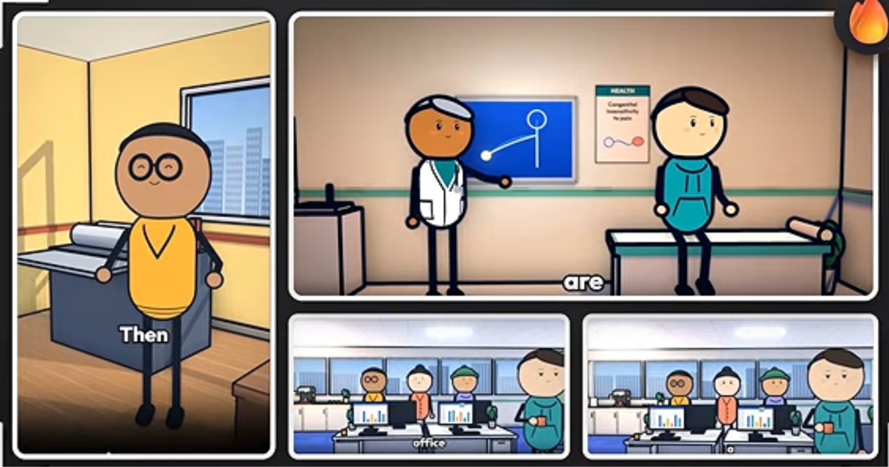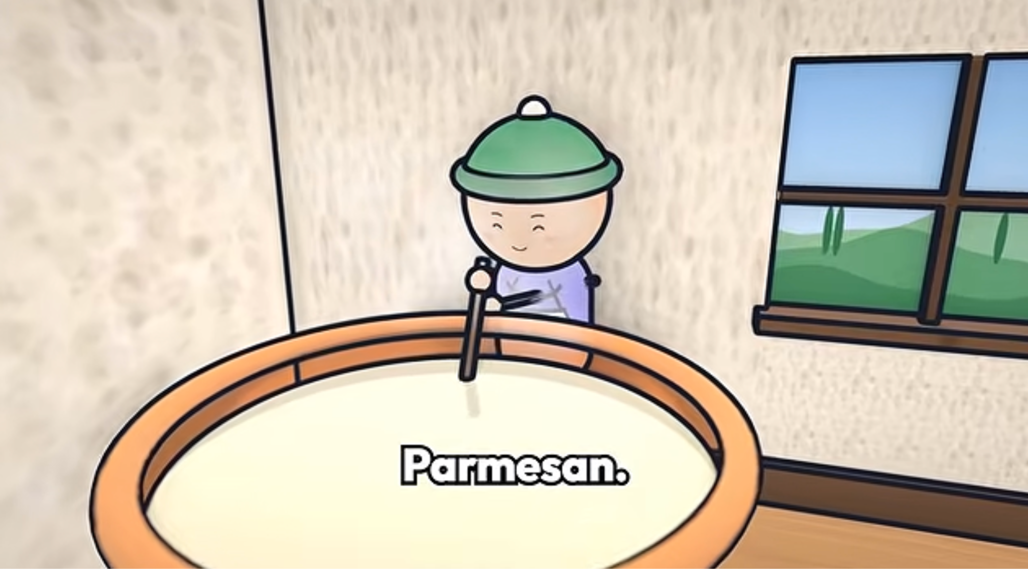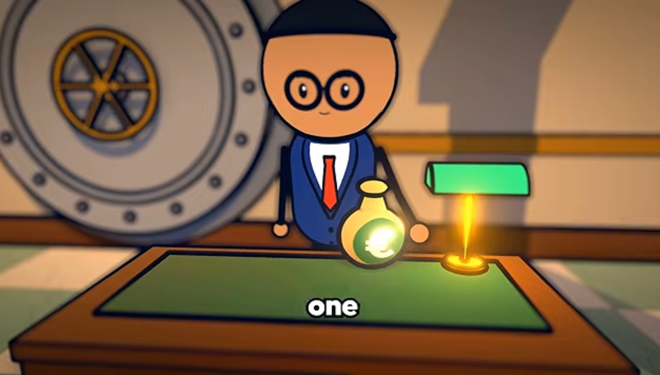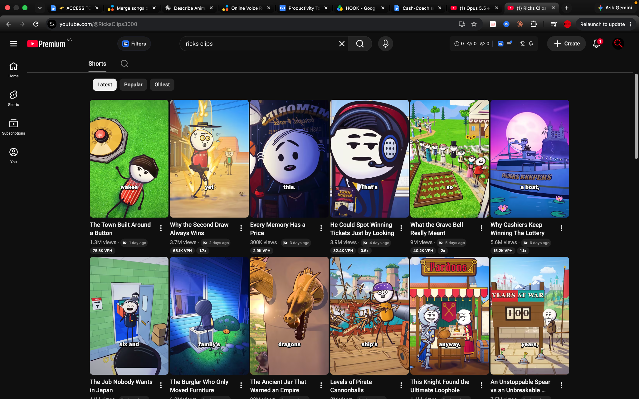
NOTE: When in doubt go with the plugin settings!
For Reference only: 2.5D Stick-Figure Cartoon Animation — Visual Style Description
A premium minimalist 2.5D stick-figure cartoon animation style combining simple, expressive characters with colorful, detailed illustrated environments. The aesthetic resembles modern YouTube educational explainers, using clean digital line art, bold black outlines, flat colors, exaggerated proportions, and cinematic visual storytelling.
CHARACTER DESIGN: Characters have oversized, nearly perfect circular heads surrounded by thick, smooth black outlines. Faces are extremely simple, featuring two tiny black oval eyes or dots, short expressive eyebrows, and small curved mouths. Emotions are communicated through eyebrow angles, eye positioning, and mouth shapes. Avoid realistic noses, ears, lips, and anatomical facial details. Heads are disproportionately large compared with narrow bodies.
BODY STRUCTURE: Torsos are simplified rounded rectangles, elongated capsules, or narrow robe-shaped silhouettes. Arms and legs consist of thin black stick lines. Hands are tiny black circles or rounded mittens, while feet are small dark ovals. Clothing uses recognizable geometric shapes, including T-shirts, hoodies, jackets, uniforms, and historical robes. Preserve consistent proportions and avoid bulky or realistic anatomy.
LINE ART AND COLORS: Use bold, clean, slightly organic black outlines with smooth curves and subtle hand-drawn imperfections. Characters feature flat, saturated colors with minimal shading. The palette includes warm yellow, teal, turquoise, navy blue, burgundy, cream, earthy brown, and pastel tones. Maintain strong contrast between characters and backgrounds. Avoid complex textures, glossy materials, and photorealistic rendering.
BACKGROUND DESIGN: Environments are more detailed than the characters but remain entirely illustrated. Create colorful cartoon offices, hospitals, historical palaces, streets, landscapes, and interiors using simplified architecture, geometric props, layered scenery, and soft atmospheric perspective. Backgrounds feature gentle gradients, subtle shadows, muted distant objects, and clear foreground-to-background separation. Characters should remain visually prominent.
CINEMATOGRAPHY: Use professionally composed wide shots, medium shots, close-ups, and insert shots. Emphasize clear silhouettes, expressive faces, environmental storytelling, and carefully positioned props. Introduce depth through layered 2D illustrations rather than realistic 3D geometry. Comic-panel layouts with thick dark borders and rounded corners may be used for comparisons and sequential storytelling.
ANIMATION LANGUAGE: Favor limited 2D cutout animation, expressive frozen poses, subtle camera movement, and hard cuts between illustrated compositions. Use slow zoom-ins, zoom-outs, or horizontal pans to create visual interest. Character actions should be communicated through clear poses rather than complex movement. For static animation, keep characters, facial features, props, and backgrounds completely motionless; animate only the camera.
FINAL VISUAL STANDARD: Crisp professional 2D educational cartoon, consistent character models, polished composition, bright illustrative environments, mobile-friendly readability, and 4K resolution. No photorealism, 3D rendering, anime anatomy, detailed fingers, muscular bodies, excessive shading, realistic fabric textures, distorted proportions, or inconsistent outlines.

MASTER STYLE — 2.5D STICK-FIGURE CARTOON WITH 3D ANIMATION
Create a premium 2.5D cartoon animation combining minimalist 2D stick-figure character designs with fully three-dimensional movement, cinematic camera perspectives, and immersive illustrated environments. The final visual appearance must resemble a clean, colorful, hand-drawn 2D educational cartoon, while character motion and environmental depth behave like a stylized 3D animated production.
CHARACTER DESIGN: Characters feature oversized, perfectly rounded heads with thick, smooth black outlines, tiny black oval eyes, expressive eyebrows, and simple curved mouths. Faces remain flat, graphic, and minimalist. Bodies consist of narrow capsule-shaped torsos, thin black stick arms and legs, tiny circular hands, and simple oval feet. Clothing uses flat geometric shapes, including hoodies, shirts, robes, coats, and historical costumes. Maintain identical proportions and recognizable character features from every camera angle.
3D CHARACTER MOVEMENT: Characters must move naturally through three-dimensional space while preserving their original 2D appearance. They can walk forward, backward, and sideways, turn around, rotate their heads and bodies, sit, stand, point, gesture, and interact with environmental objects. Their limbs should animate with smooth joint rotations, consistent volume, convincing weight shifts, and coordinated walking cycles. Characters must remain thin, simple, and cartoon-like during rotation, without becoming realistic humans or bulky 3D models.
ILLUSTRATION AND RENDERING: Use flat cel-shaded materials, bold black contour outlines, smooth vector-like surfaces, minimal shadows, and bright cartoon colors. Preserve the appearance of hand-drawn digital illustrations from every angle. Avoid glossy plastic surfaces, realistic textures, complex facial geometry, and photorealistic lighting.
3D BACKGROUND DESIGN: Create fully dimensional environments styled to resemble colorful 2D illustrations. Buildings, offices, palaces, streets, furniture, staircases, windows, and environmental props must possess genuine spatial depth, realistic placement, and consistent perspective. Use layered architecture, simplified geometric modeling, pastel color palettes, soft gradients, and subtle ambient shadows. Backgrounds should resemble beautifully illustrated cartoon worlds rather than realistic 3D environments.
SPATIAL INTERACTION: Characters must convincingly occupy the environments. They can walk behind furniture, pass through doorways, move between foreground and background layers, sit on chairs, and interact with props. Maintain correct perspective, object occlusion, floor contact, and character scaling as they move through the scene.
CINEMATOGRAPHY: Use cinematic wide shots, medium shots, close-ups, tracking shots, over-the-shoulder perspectives, and dynamic three-quarter camera angles. Cameras may pan, dolly, orbit, track characters, or change viewpoints while preserving the flat cartoon rendering. Allow natural parallax and dimensional perspective.
ANIMATION QUALITY: Smooth 3D spatial movement with stylized 2D character rendering, expressive poses, controlled squash-and-stretch, natural walking cycles, and coherent environmental interaction. The animation must feel dimensional, immersive, and professionally directed without losing its minimalist stickman identity.
OUTPUT: Premium 2.5D educational cartoon, 4K, 16:9, crisp outlines, bright illustrated scenery, consistent characters, smooth spatial animation, and cinematic storytelling.
NEGATIVE PROMPT: No photorealism, Pixar-style rendering, realistic anatomy, muscular bodies, detailed fingers, glossy plastic textures, anime faces, inconsistent proportions, flat cardboard environments, rigid sprite rotation, unnatural walking, floating feet, distorted heads, or inconsistent outlines.

Animate this scene using full 3D spatial movement while maintaining the exact visual appearance of a flat 2D stick-figure cartoon. The character must retain its oversized circular head, minimal facial details, thin black limbs, simple geometric torso, and bold outlines during every turn and camera-angle change.
Use believable three-dimensional walking, turning, head rotation, gestures, and interaction with the environment. Maintain accurate floor contact, natural weight transfer, consistent limb lengths, and correct perspective.
The background must behave like a fully constructed 3D environment with architectural volume, realistic spatial relationships, foreground-background occlusion, and natural parallax, but all surfaces must retain flat cel-shaded, hand-illustrated cartoon styling.
Use cinematic camera tracking, three-quarter views, perspective changes, and smooth camera movement. Characters must never look like flat cardboard cutouts rotating in space. Their appearance stays 2D, but their physical motion, camera angles, and environment must behave in three dimensions.
Maintain consistent character identity, clothing, proportions, outlines, colors, and environmental layout throughout the entire shot. No photorealism, glossy rendering, realistic human anatomy, or unintentional character deformation.

CHANNEL CONFIGURATION — MASTER SETTINGS
- Channel Name: Oddly Human
- Recurring Cast: ODD — the main stick-figure narrator and mascot. Supporting characters change depending on the story. All characters maintain the same 2.5D cartoon visual style.
- Colors to Keep: Teal, navy blue, warm yellow, white, sky blue, and earthy tones. Use bold black outlines and colorful illustrated backgrounds.
- Colors to Avoid: Excessive neon colors, dull monochromatic palettes, overly dark scenes, and inconsistent character colors.
- Topics to Avoid: Politics, graphic violence, explicit content, religious controversy, misinformation, and overly disturbing subjects.
- ElevenLabs Voice: Will be chosen
  - Stability: 50%
  - Similarity: 75%
  - Style Exaggeration: 20%
  - Speed: 1.0×
  - Delivery: Curious, expressive, conversational, and engaging.
  - Settings are recommended starting values, not previously confirmed presets.
- Content Priority: YouTube Shorts first (45–60 seconds). Expand successful topics into 4–8-minute long-form videos. Ask to confirm.
- Music Mood: Playful, mysterious, cinematic, and curiosity-driven. Use subtle instrumental background music, light percussion, gentle suspense, and occasional comedic accents. Keep music below narration.
- Visual Style: 2.5D stick-figure animation — flat 2D cartoon appearance with full 3D character movement, cinematic camera angles, and dimensional illustrated backgrounds.
- Overall Channel Identity: Entertaining educational storytelling focused on strange history, human behavior, surprising science, forgotten inventions, and fascinating everyday mysteries.
Note: Confirm from the User where necessary

